Issues in Self-Checkout
Graeme Williams
carryonwilliams@gmail.com

This note discussed issues I’ve come across using self-checkout at public libraries in Las Vegas, Nevada and Frederick, Maryland.
License: CC BY-NC-SA 4.0, https://creativecommons.org/licenses/by-nc-sa/4.0/

Bar code scanning or RFID??
The issues you’ll face depend on whether items are checked out using a scanner, or an RFID reader, or both.
Las Vegas has RFID tags on some but not all items, so you can check out some items using either RFID or scanning, but some items only using a scanner. This puts a lot of stress on the signage around the self-checkout stations. I include a couple of examples below.
Frederick does not have RFID tags, so all items must be scanned.

Finding a self-checkout station
It should be easy for patrons, including patrons who have never visited the library before, to find a self-checkout station. This means they should be labeled with signs that are readable from across the library (which sounds obvious but is not true in Frederick).
Las Vegas simplifies this problem a bit by putting a bank of stations near the exit.
I guess you can choose how to distribute stations across each branch.

How to use a self-checkout station
It should be easy for patrons, including patrons who have never visited the library before, to figure out how to use a self-checkout station. Here are a few things that can become issues:
- Can I use the bar code scanner to read my library card? One possible problem is that the prompt on the screen doesn’t mention it. Like this:
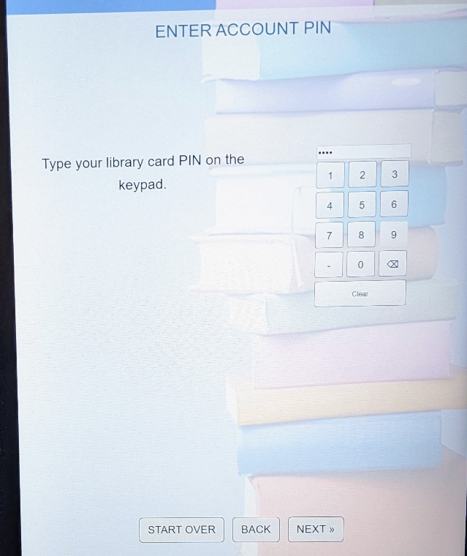
Figure 1LV branch A checkout screen
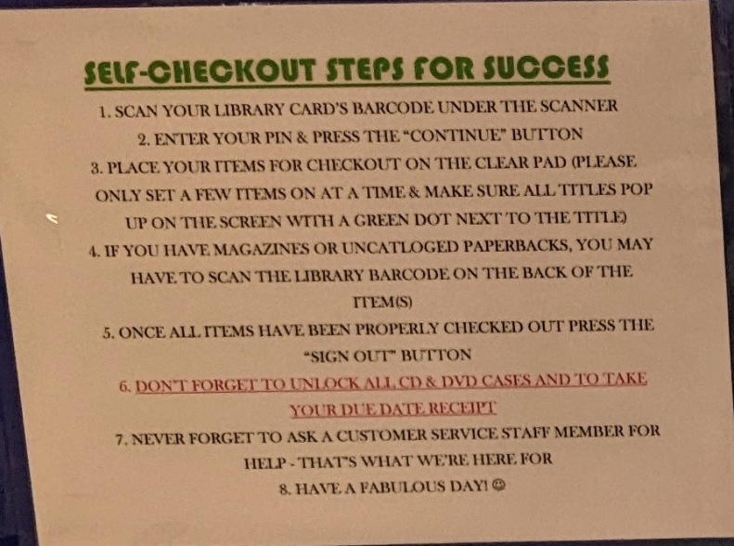
- If checkout uses RFID, can I use RFID for everything? Can the system handle multiple items at once. Here’s the sign that was posted next to the screen in figure 1:
Figure 2 LV branch A checkout sign

(Note that this sign does mention scanning your library card.) The problem with these instructions is that (i) it looks like there are seven steps, “1” through “7”, but steps 3 and 4 are alternatives, not sequential steps, (ii) the phrase “a few items” in step 3 is both too vague and two conservative, (iii) step 6 is really two separate steps and the second step applies to everyone although the first one doesn’t, and (iv) step 7 isn’t a step at all, just an offer of help.
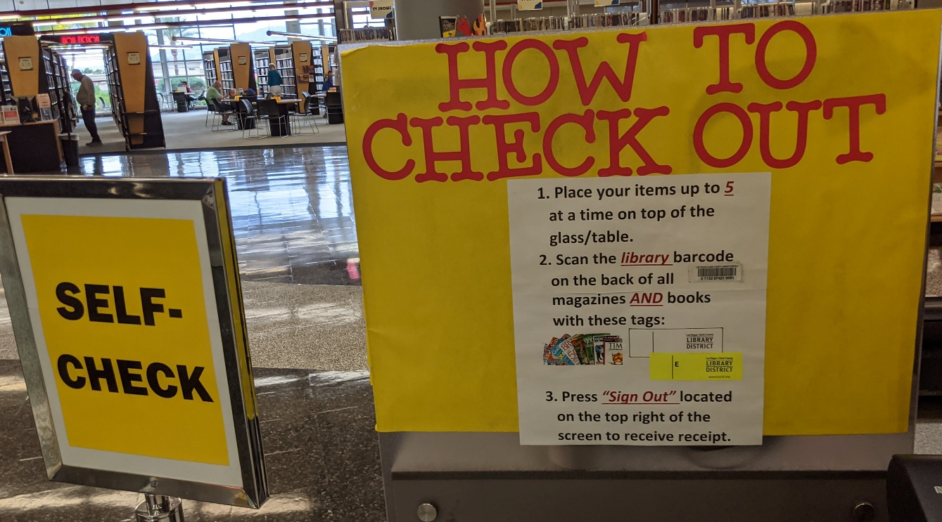
Here’s a different branch of the Las Vegas library trying to solve the same problem:
Figure 3 LV branch B checkout sign

Again, steps 1 and 2 are alternatives, not sequential steps. On the other hand, this sign includes two useful pieces of information: you can stack up to five items on the RFID reader, and for items without an RFID tag, you should scan the library barcode, not the ISBN (!).
The only advice I can give is to have a technical writer write, or at least review, any posted instructions, and then have some ten- and seventy-year-olds test them out.

Ergonomics
It should be physically comfortable to use a self-checkout station. You should be able to use it with one hand (which I’m pretty sure is an ADA requirement). The issue I’ve seen is that a station doesn’t have both a space on the left for unscanned items and a space on the right for scanned items. Although this station (from the same Las Vegas branch as figures 1 and 2) is a mess, it has the best ergonomics, since there’s enough space around it:
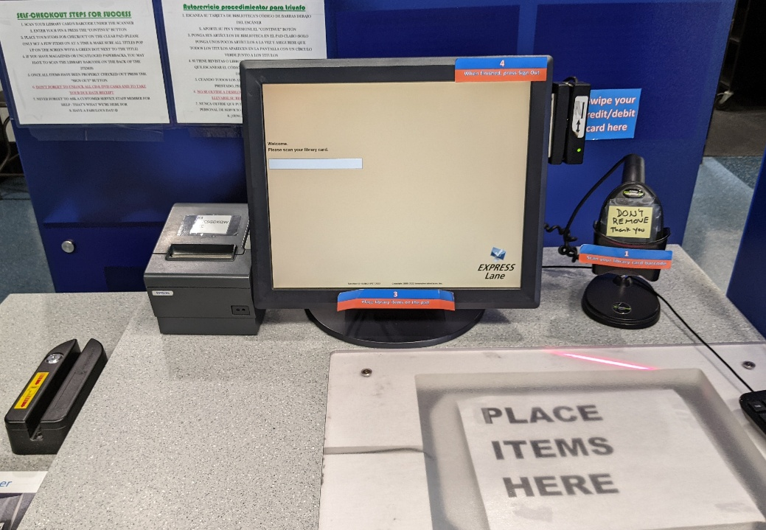
Figure 4 LV branch A older checkout station
The other advantage of this mess is that the bar code scanner is obvious. For the station in figure 1, the scanner is hidden under the screen, so it’s not obvious at all.
Figure 5 LV branch A older checkout station
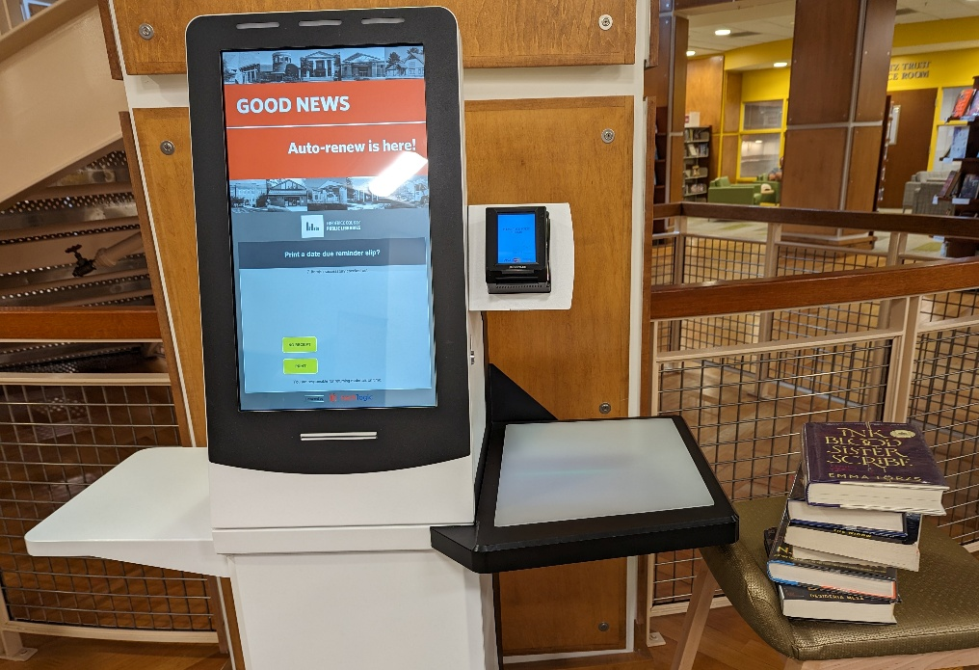
Here’s how I used a stool to solve the lack of a right-hand shelf in Frederick:
Figure 6 Frederick checkout station

You can see the scanner on the right of the screen. I eventually figured out that after I scanned each item, I could flip it front cover up (so the barcode wouldn’t get repeatedly scanned) and put it on the shelf under the scanner.

How well does the barcode scanner work?
When I moved from Las Vegas to Frederick, the scanners in Frederick felt so unreliable that I wanted to take a hammer to them. Part of the problem, which you can see in the figure above, is that the scanner is hanging in mid-air, so it’s not obvious where to position your library card or book. After several years using it, I now have enough muscle memory that it’s reliable — but not completely comfortable. (The correct position, by the way, is in the air about halfway between the scanner and the shelf below it.)
I’m still convinced that the scanners in Las Vegas were more forgiving in terms of how accurately you needed to position an item.
The problem is that unless they’re very self-aware, a librarian testing a scanner might not be aware of the effort needed to accurately position an item, effort that is going to be immediately and painfully obvious to a patron using the system for the first time.

Help
At my local branch in Las Vegas, there was a staff member standing near the self-checkout systems ready to offer help to any patron who seems to be having difficulty.
I’m in two minds about this. It’s good to have help easily available, but it seems a bit intrusive to have someone hovering over you.

Coda
I love self-checkout. I love being able to walk into the library and walk out with a book in a few minutes — without talking to anyone. I strongly believe that patrons should be able to get the same level of service with or without talking to a librarian, and that naturally puts a lot of emphasis on layout and signage.
I believe that librarians don’t know what they don’t know. I trust that librarians can organize information, collections and services, but I don’t see much evidence that librarians can communicate instructions for completing a task. I believe that librarians need technical writers for their specific skills just like they need electricians and plumbers. (I am not a technical writer, in case you were wondering.)

